APPENDIX

This appendix include additional figures and tables to supplement findings reported in the article, such as: sensor location, descriptive statistics for all readings (not just paired readings), intra-individual bias for repeated measurements, false positive rate tables for Masimo, Nellcor and both sensors at cut-offs of SaO₂ <70 and < 80, and bivariable and multivariable analysis of clinical characteristics and absolute bias categorised as ≤3% and >3% in all readings (both paired and unpaired).

Table A1: Location of SpO₂ sensors on body by sensor type
Sensor Location |  | All Readings |  |  |  |  |  | Paired Readings
 |  | Massimo  (N=16547) |  | Nellcor  (N=9761) |  | Total (N=26308) |  | Massimo  (N=9382) |  | Nellcor  (N=9382) |  | Total (N=18764)
 |  | N | % | n | % | n | % | n | % | n | % | n | %
Foot  (1st, 2nd, 3rd, 4th toe) | Left | 1448 | 8.8 | 1115 | 11.4 | 2563 | 9.7 | 840 | 9.0 | 1083 | 11.5 | 1923 | 10.3
Foot  (1st, 2nd, 3rd, 4th toe) | Right | 1438 | 8.7 | 966 | 9.9 | 2404 | 9.1 | 899 | 9.6 | 936 | 10.0 | 1835 | 9.8
Big toe | Left | 1506 | 9.1 | 773 | 7.9 | 2279 | 8.7 | 722 | 7.7 | 756 | 8.1 | 1478 | 7.9
Big toe | Right | 1500 | 9.1 | 659 | 6.8 | 2159 | 8.2 | 769 | 8.2 | 634 | 6.8 | 1403 | 7.5
Hand/wrist  (1st, 2nd, 3rd, 4th finger) | Left | 2522 | 15.2 | 1442 | 14.8 | 3964 | 15.1 | 1453 | 15.5 | 1400 | 14.9 | 2853 | 15.2
Hand/wrist  (1st, 2nd, 3rd, 4th finger) | Right | 1974 | 11.9 | 1325 | 13.6 | 3299 | 12.5 | 1406 | 15.0 | 1289 | 13.7 | 2695 | 14.4
Thumb | Left | 1340 | 8.1 | 556 | 5.7 | 1896 | 7.2 | 674 | 7.2 | 536 | 5.7 | 1211 | 6.5
Thumb | Right | 1040 | 6.3 | 557 | 5.7 | 1597 | 6.1 | 659 | 7.0 | 529 | 5.6 | 1188 | 6.3
Earlobe | Left | 38 | 0.2 | 6 | 0.1 | 44 | 0.2 | 16 | 0.2 | 4 | 0.04 | 20 | 0.1
Earlobe | Right | 48 | 0.3 | 7 | 0.1 | 55 | 0.2 | 18 | 0.2 | 6 | 0.1 | 24 | 0.1
Other |  | 32 | 0.2 | 14 | 0.1 | 46 | 0.2 | 6 | 0.1 | 14 | 0.2 | 20 | 0.1
Missing |  | 3661 | 22.1 | 2341 | 24.0 | 6002 | 22.8 | 1920 | 20.5 | 2195 | 23.4 | 4115 | 21.9
Details of the location of the sensor for all SpO₂ readings by sensor type.

Table A2: Descriptive statistics for bias (SpO₂ – SaO₂) for all readings
SaO₂ Category | Massimo |  |  |  |  | Nellcor |  |  |  |  |  | All readings
SaO₂ Category | N | Min | Max | Med | IQR | N | Min | Max | Med | IQR | p | N | Min | Max | Med | IQR
Entire SaO₂ range | 16547 | -70 | 59 | 1 | 2 | 9761 | -77 | 66.4 | 0.2 | 3.6 | <0.001 | 26308 | -77 | 66.4 | 1 | 3
SaO₂ < 70 | 333 | -19 | 59 | 12 | 17 | 274 | -4.9 | 66.4 | 11.3 | 13.7 | 0.640 | 607 | -19 | 66.4 | 11.4 | 15
70 ≤ SaO₂ < 75 | 329 | -41 | 30 | 6 | 8 | 272 | -10.6 | 29 | 5.9 | 6.8 | 0.246 | 601 | -41 | 30 | 5.9 | 6.8
75 ≤ SaO₂ < 80 | 541 | -30 | 25 | 4 | 7 | 470 | -6.5 | 25 | 4.4 | 6.1 | 0.114 | 1011 | -30 | 25 | 4 | 6.9
80 ≤ SaO₂ < 88 | 1017 | -35 | 19 | 4 | 7 | 837 | -16.9 | 20 | 3 | 6.6 | 0.028 | 1854 | -35 | 20 | 3.4 | 7
88 ≤ SaO₂ < 92 | 993 | -41 | 12 | 3 | 5 | 695 | -27.8 | 12 | 2 | 5.3 | <0.001 | 1688 | -27.8 | 12 | 2 | 5.3
SaO₂ ≥ 92 | 13334 | -70 | 8 | 1 | 3 | 7213 | -77 | 8 | -0.2 | 3 | <0.001 | 20547 | -77 | 8 | 0 | 2.6

Figure A2a-b: Intra-individual bias for repeated measurements

Investigation of intra-patient variability in relation to bias over time has been undertaken. Initial readings are generally taken when SaO₂ is much lower, which has been demonstrated above to lead to greater bias. Therefore, bias over repeated measurements changes, is not constant for each individual subject over the saturation range and it appears to be primarily due to the shift in the SaO₂ readings.

Figures A2a-b show, over time, for paired Massimo readings only (Similar findings for Nellcor), whether bias changes compared to the first reading (i.e. if they were biased originally using the absolute ≥3% cut-off value) or the previous reading – blue is started off biased ≥3%, and still biased, orange is started off biased ≥3% but becomes over time not biased, grey is started off not biased and becomes over time biased, yellow is no bias throughout all measurements.

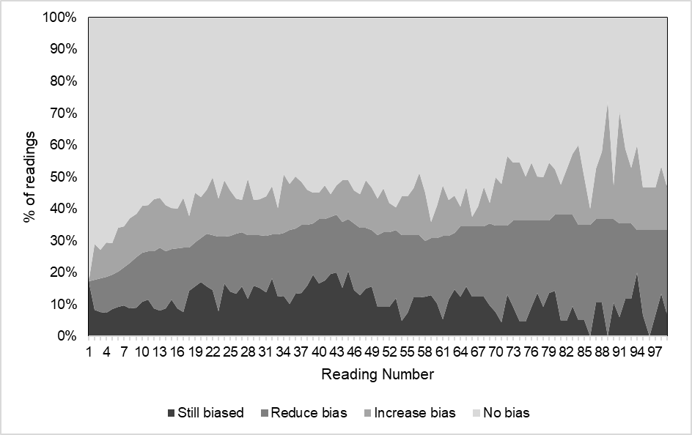 | 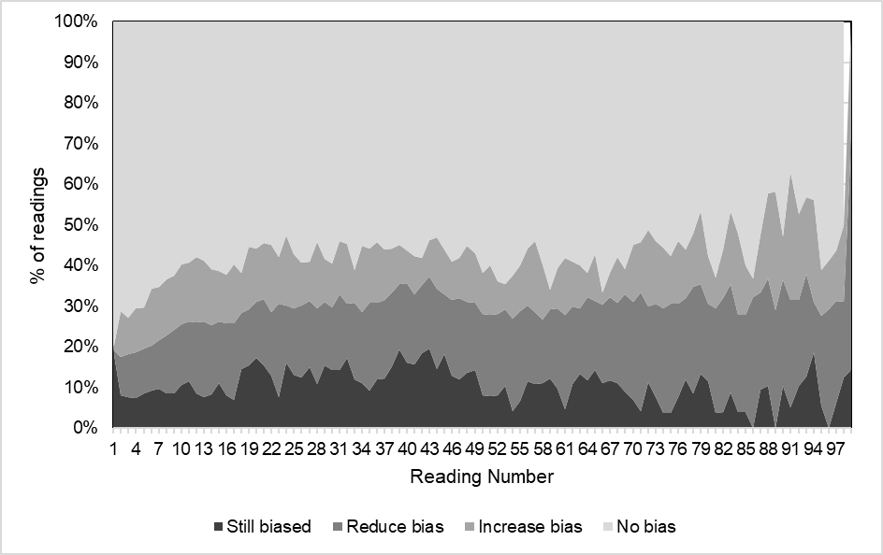
Figure A2a: Intra-participant bias in comparison to first reading for first 100 readings | Figure A2b: Intra-participant bias in comparison to previous reading for first 100 readings

Table A3: False positive rate – SpO₂ hypoxaemia vs. true hypoxaemia (Massimo sensor)
Hypoxaemia based on SpO₂ | True Hypoxaemia (SaO₂<88) |  |  |  | Total
Hypoxaemia based on SpO₂ | No |  | Yes
Hypoxaemia based on SpO₂ | n | % | n | % | n | %
No | 14073 | 85.1 | 678 | 4.1 | 14749 | 89.2
Yes | 254 | 1.5 | 1544 | 9.3 | 1798 | 10.9
Total | 14327 | 86.6 | 2220 | 13.4 | 16547 | 100.0
p<0.001; kappa = 0.737, p<0.001
Sensitivity: 69.5% (95% CI 67.6%, 71.5%)
Specificity: 98.2% (95% CI 98.0%, 98.4%)
Positive predictive value: 85.9% (84.2%, 87.5%)
Negative predictive value: 95.4% (95.1%, 95.7%)

Table A4: False positive rate – SpO₂ hypoxaemia vs. true hypoxaemia (Nellcor sensor)
Hypoxaemia based on SpO₂ | True Hypoxaemia (SaO₂<88) |  |  |  | Total
Hypoxaemia based on SpO₂ | No |  | Yes
Hypoxaemia based on SpO₂ | n | % | n | % | n | %
No | 7629 | 78.2 | 489 | 5.0 | 8118 | 83.2
Yes | 279 | 2.9 | 1364 | 14.0 | 1643 | 16.8
Total | 7908 | 81.0 | 1853 | 19.0 | 9761 | 100.0
p<0.001; kappa = 0.733, p<0.001
Sensitivity: 73.6% (95% CI 71.5%, 75.6%)
Specificity: 96.5% (95% CI 96.0%, 96.9%)
Positive predictive value: 83.0% (81.1%, 84.8%)
Negative predictive value: 94.0% (93.4%, 94.5%)

Table A5: False positive rate – SpO₂ hypoxaemia vs. true hypoxaemia (both sensors)
Hypoxaemia based on SpO₂ | True Hypoxaemia (SaO₂<80) |  |  |  | Total
Hypoxaemia based on SpO₂ | No |  | Yes
Hypoxaemia based on SpO₂ | n | % | n | % | n | %
No | 23865 | 90.7 | 1081 | 4.1 | 24964 | 94.8
Yes | 224 | 0.9 | 1138 | 4.3 | 1362 | 5.2
Total | 24089 | 91.6 | 2219 | 8.4 | 26308 | 100.0
p<0.001; kappa = 0.611; p<0.001
Sensitivity: 51.3% (95% CI 49.2%, 53.4%)
Specificity: 99.1% (95% CI 98.9%, 99.2%)
Positive predictive value: 83.6% (81.5%, 85.5%)
Negative predictive value: 95.7% (95.4%, 95.9%)

Table A6: False positive rate – SpO₂ hypoxaemia vs. true hypoxaemia (Massimo sensor) with threshold set at <80%
Hypoxaemia based on SpO₂ | True Hypoxaemia (SaO₂<80) |  |  |  | Total
Hypoxaemia based on SpO₂ | No |  | Yes
Hypoxaemia based on SpO₂ | n | % | n | % | n | %
No | 15224 | 92.0 | 579 | 3.5 | 15803 | 95.5
Yes | 120 | 0.7 | 624 | 3.8 | 744 | 4.5
Total | 15344 | 92.7 | 1203 | 7.3 | 16547 | 100.0
p<0.001; kappa = 0.620, p<0.001
Sensitivity: 51.9% (95% CI 49.0%, 54.7%)
Specificity: 99.2% (95% CI 99.1%, 99.4%)
Positive predictive value: 83.9% (81.0%, 86.4%)
Negative predictive value: 96.3% (96.0%, 96.6%)

Table A7: False positive rate – SpO₂ hypoxaemia vs. true hypoxaemia (Nellcor sensor) with threshold set at <80
Hypoxaemia based on SpO₂ | True Hypoxaemia (SaO₂<80) |  |  |  | Total
Hypoxaemia based on SpO₂ | No |  | Yes
Hypoxaemia based on SpO₂ | n | % | n | % | n | %
No | 8641 | 88.5 | 502 | 5.1 | 9143 | 93.7
Yes | 104 | 1.1 | 514 | 5.3 | 618 | 6.3
Total | 8745 | 89.6 | 1016 | 10.4 | 9761 | 100.0
p<0.001; kappa = 0.597, p<0.001
Sensitivity: 50.6% (95% CI 47.5%, 53.7%)
Specificity: 98.8% (95% CI 98.6%, 99.0%)
Positive predictive value: 83.2% (80.0%, 86.0%)
Negative predictive value: 94.5% (94.0%, 95.0%)

Table A8: False positive rate – SpO₂ hypoxaemia vs. true hypoxaemia for both sensors with threshold set at <70%
Hypoxaemia based on SpO₂ | True Hypoxaemia (SaO₂<70) |  |  |  | Total
Hypoxaemia based on SpO₂ | No |  | Yes
Hypoxaemia based on SpO₂ | n | % | n | % | n | %
No | 17993 | 68.4 | 4874 | 18.5 | 22867 | 86.9
Yes | 278 | 1.1 | 3163 | 12.0 | 3441 | 13.1
Total | 18271 | 69.5 | 8037 | 30.6 | 26308 | 100.0
p<0.001; kappa = 0.451; p<0.001
Sensitivity: 39.4% (95% CI 38.3%, 40.4%)
Specificity: 98.5% (95% CI 98.3%, 98.7%)
Positive predictive value: 91.9% (91.0%, 92.8%)
Negative predictive value: 78.7% (78.1%, 79.2%)

Table A9: False positive rate – SpO₂ hypoxaemia vs. true hypoxaemia (Massimo sensor)
Hypoxaemia based on SpO₂ | True Hypoxaemia (SaO₂<70) |  |  |  | Total
Hypoxaemia based on SpO₂ | No |  | Yes
Hypoxaemia based on SpO₂ | n | % | n | % | n | %
No | 11779 | 71.2 | 2970 | 18.0 | 14749 | 89.1
Yes | 150 | 0.9 | 1648 | 10.0 | 1798 | 10.9
Total | 11929 | 72.1 | 4618 | 27.9 | 16547 | 100.0
p<0.001; kappa = 0.424, p<0.001
Sensitivity: 35.7% (95% CI 34.3%, 37.1%)
Specificity: 98.7% (95% CI 98.5%, 98.9%)
Positive predictive value: 91.7% (90.3%, 92.9%)
Negative predictive value: 79.9% (79.2%, 80.5%)

Table A10: False positive rate – SpO₂ hypoxaemia vs. true hypoxaemia (Nellcor sensor)
Hypoxaemia based on SpO₂ | True Hypoxaemia (SaO₂<70) |  |  |  | Total
Hypoxaemia based on SpO₂ | No |  | Yes
Hypoxaemia based on SpO₂ | n | % | n | % | n | %
No | 6214 | 63.7 | 1904 | 19.5 | 8118 | 83.2
Yes | 128 | 1.3 | 1515 | 15.5 | 1643 | 16.8
Total | 6342 | 65.0 | 3419 | 35.0 | 9761 | 100.0
p<0.001; kappa = 0.480, p<0.001
Sensitivity: 44.3% (95% CI 42.6%, 46.0%)
Specificity: 98.0% (95% CI 97.6%, 98.3%)
Positive predictive value: 92.2% (90.8%, 93.5%)
Negative predictive value: 76.5% (75.6%, 77.5%)

Table A11: Bivariable and multivariable analysis of clinical characteristics and absolute bias categorised as ≤3% and >3% (all readings, including paired and unpaired readings)
Variable |  | N | Absolute Bias ≤3% (N=19821) |  | Absolute Bias >3% (N=6487) |  | Bivariable Analysis |  |  | Multivariable Analysis  (N=26161)
 |  |  | n | % | n | % | OR | 95% CI | p | aOR | 95% CI | p
Diagnosis | CVS – cyanotic | 4978 | 3211 | 16.2 | 1767 | 27.2 | 3.15 | 2.34, 4.23 | <0.001 | 0.92 | 0.76, 1.11 | 0.392
Diagnosis | CVS – acyanotic (ref) | 8214 | 6292 | 31.7 | 1922 | 29.6 | 1 | - | - | 1 | - | -
Diagnosis | Sepsis | 3529 | 2893 | 14.6 | 636 | 9.8 | 0.73 | 0.53, 1.02 | 0.066 | 1.40 | 1.16, 1.70 | <0.001
Diagnosis | Respiratory | 5143 | 3579 | 18.1 | 1564 | 24.1 | 1.49 | 1.09, 2.03 | 0.013 | 1.35 | 1.12, 1.62 | 0.001
Diagnosis | Cardiac arrest | 910 | 788 | 4.0 | 122 | 1.9 | 0.78 | 0.49, 1.24 | 0.293 | 1.69 | 1.27, 2.24 | <0.001
Diagnosis | Post-op | 2010 | 1662 | 8.4 | 348 | 5.4 | 0.41 | 0.30, 0.57 | <0.001 | 1.05 | 0.88, 1.25 | 0.609
Diagnosis | Other | 1524 | 1396 | 7.0 | 128 | 2.0 | 0.38 | 0.25, 0.58 | <0.001 | 1.20 | 0.96, 1.50 | 0.118
Age at ICU admission (n, %) | 0-<2 years (ref) | 18897 | 13404 | 67.6 | 5493 | 84.7 | 1 | - | - | -
Age at ICU admission (n, %) | 2-<17 years | 7411 | 6417 | 32.4 | 994 | 15.3 | 0.31 | 0.25, 0.38 | <0.001 | -
Weight at admission (kg)* |  | 26308 | 6.8 | 12.3 | 4.3 | 4.3 | 0.50 | 0.44, 0.56 | <0.001 | 0.86 | 0.80, 0.93 | <0.001
Gender (n, %) | Male (ref) | 12580 | 9226 | 46.6 | 3354 | 51.7 | 1 | - | - | 1 | - | -
Gender (n, %) | Female | 13728 | 10595 | 53.5 | 3133 | 48.3 | 0.94 | 0.76, 1.16 | 0.581 | 1.08 | 0.96, 1.21 | 0.181
Ethnicity (n, %) | Not ATSI (ref) | 23647 | 17880 | 90.2 | 5767 | 88.9 | 1 | - | - | 1 | - | -
Ethnicity (n, %) | ATSI | 2661 | 1941 | 9.8 | 720 | 11.1 | 0.88 | 0.61, 1.26 | 0.484 | 1.26 | 1.03, 1.53 | 0.022
Oximeter type | Massimo (ref) | 16547 | 13142 | 66.3 | 3405 | 52.5 | 1 | - | - | 1 | - | -
Oximeter type | Nellcor | 9761 | 6679 | 33.7 | 3082 | 47.5 | 1.52 | 1.42, 1.62 | <0.001 | 3.82 | 3.45, 4.22 | <0.001
SaO₂ Category | SaO₂ < 80 | 2219 | 613 | 3.1 | 1606 | 24.8 | 26.91 | 22.87, 31.66 | <0.001 | 5.51 | 4.20, 7.22 | <0.001
SaO₂ Category | 80 ≤ SaO₂ < 88 | 1854 | 794 | 4.0 | 1060 | 16.3 | 9.98 | 8.74, 11.41 | <0.001 | 4.10 | 3.19, 5.27 | <0.001
SaO₂ Category | 88 ≤ SaO₂ < 92 | 1688 | 835 | 4.2 | 853 | 13.2 | 5.40 | 4.80, 6.07 | <0.001 | 3.53 | 2.76, 4.52 | <0.001
SaO₂ Category | SaO₂ ≥ 92 (ref) | 20547 | 17579 | 88.7 | 2968 | 45.8 | 1 | - | - | 1 | - | -
Temperature^ |  | 16828 | 36.6 | 1.0 | 36.5 | 1.1 | 1.03 | 0.99, 1.08 | 0.135 | -
Lactate* |  | 26161 | 1.1 | 0.8 | 1.2 | 0.9 | 1.37 | 1.28, 1.47 | <0.001 | 1.11 | 1.03. 1.20 | 0.007
Total Hb^ |  | 26285 | 114.4 | 22.3 | 122.7 | 21.8 | 1.008 | 1.006, 1.01 | <0.001 | -
pH | <7.3 | 4056 | 2860 | 14.5 | 1196 | 18.5 | 1.58 | 1.44, 1.73 | <0.001 | -
pH | 7.3-7.45 (ref) | 19939 | 15172 | 76.8 | 4760 | 73.8 | 1 | - | - | -
pH | >7.45 | 2212 | 1714 | 8.7 | 498 | 7.7 | 0.89 | 0.79, 1.01 | 0.066 | -
Oxygenation index | None (ref) | 7710 | 6725 | 54.8 | 985 | 25.7 | 1 | - | - | -
Oxygenation index | Mild | 5693 | 4277 | 34.8 | 1416 | 36.9 | 1.91 | 1.71, 2.12 | <0.001 | -
Oxygenation index | Moderate | 2074 | 1075 | 8.8 | 999 | 26.0 | 5.53 | 4.79, 6.37 | <0.001 | -
Oxygenation index | Severe | 636 | 198 | 1.6 | 438 | 11.4 | 11.62 | 9.24, 14.62 | <0.001 | -
Oxygen saturation index | None (ref) | 8759 | 7555 | 67.7 | 1204 | 40.8 | 1 | - | - | -
Oxygen saturation index | Mild | 3789 | 2739 | 24.5 | 1050 | 35.6 | 2.06 | 1.82, 2.32 | <0.001 | -
Oxygen saturation index | Moderate | 1296 | 751 | 6.7 | 545 | 18.5 | 3.33 | 2.82, 3.93 | <0.001 | -
Oxygen saturation index | Severe | 270 | 121 | 1.1 | 149 | 5.1 | 6.18 | 4.53, 8.43 | <0.001 | -
Ventilated | No (ref) | 9903 | 7325 | 37.0 | 2578 | 39.7 | 1 | - | - | 1 | - | -
Ventilated | Yes | 16405 | 12496 | 63.0 | 3909 | 60.3 | 0.89 | 0.83, 0.96 | 0.002 | 0.99 | 0.91, 1.08 | 0.908
Inotropes | No (ref) | 18119 | 14256 | 71.9 | 3863 | 59.6 | 1 | - | - | -
Inotropes | Yes | 8189 | 5565 | 28.1 | 2624 | 40.5 | 1.32 | 1.22, 1.42 | <0.001 | -
Vasodilators | No (ref) | 16710 | 12845 | 64.8 | 3865 | 59.6 | 1 | - | - | -
Vasodilators | Yes | 9598 | 6976 | 35.2 | 2622 | 40.4 | 0.95 | 0.88, 1.03 | 0.237 | -
Vasoconstrictors | No (ref) | 21091 | 16199 | 81.7 | 4892 | 75.4 | 1 | - | - | 1 | - | -
Vasoconstrictors | Yes | 5217 | 3622 | 18.3 | 1595 | 24.6 | 1.27 | 1.16, 1.39 | <0.001 | 1.17 | 1.04, 1.31 | 0.009
OR odds ratio; CI confidence interval; * median (interquartile range), log-transformation used for bivariable analysis; ^ mean (standard deviation)

